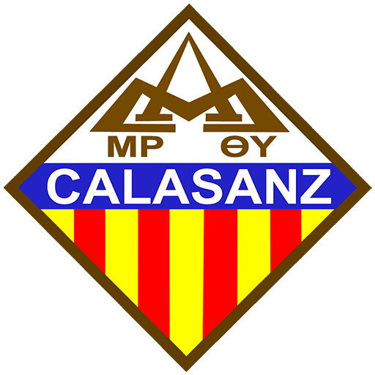

Colegio Calasanz - León
Temario de examen de admisión 2025
Inglés como segunda lengua - 10mo grado

Vocabulary Focus
- Vocabulary to talk about pollution and the environment
- Vocabulary to talk about parts of the body
- Vocabulary to describe clothes, accessories, and appearance
- Vocabulary to talk about professions
- Subject pronouns, object pronouns, reflexive pronouns, possessive pronouns
- Basic regular verbs
- Basic irregular verbs
Grammar Focus
- Simple Present – affirmative, negative, questions, and short answers
- Present continuous
- Simple Past – affirmative, negative, questions, and short answers
- Past continuous
- Present Perfect simple
- Present Perfect Continuous

