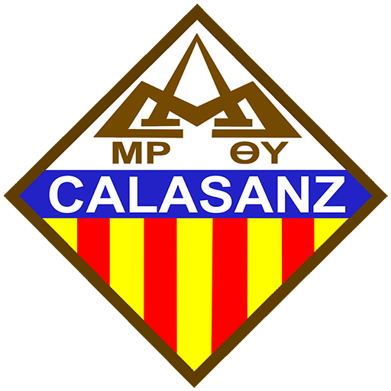**Colegio Calasanz - León**

**Temario de examen de admisión 2025**

**Inglés como segunda lengua - 11mo grado**

|  |
| --- |
| **Vocabulary Focus**   1. Vocabulary to talk about family 2. Vocabulary to talk about parts of the body 3. Vocabulary to talk about basic technology 4. Vocabulary to talk about professions 5. Subject pronouns, object pronouns, reflexive pronouns, possessive pronouns 6. Basic regular verbs 7. Basic irregular verbs   **Grammar Focus**   1. Simple Present – affirmative, negative, questions, and short answers 2. Present continuous 3. Simple Past – affirmative, negative, questions, and short answers 4. Past continuous 5. Present perfect simple 6. Past perfect simple |